COMMUNICATION PROTOCOLS
Learn about communication protocols such as UART, I2C, SPI with help of Arduino or Sensor
Introduction for all: -
https://youtu.be/IyGwvGzrqp8?si=5wVj0WeCUxnk-vPj

UART
Source: -
https://youtu.be/sTHckUyxwp8?si=Scz6zy8hcX1m6O_0
Includes another example to try: -
https://youtu.be/P0O9sVRe15I?si=qZstMD7YXeKkEmFK

Circuit: -
For controlling blinking rate of Arduino 2 from Arduino 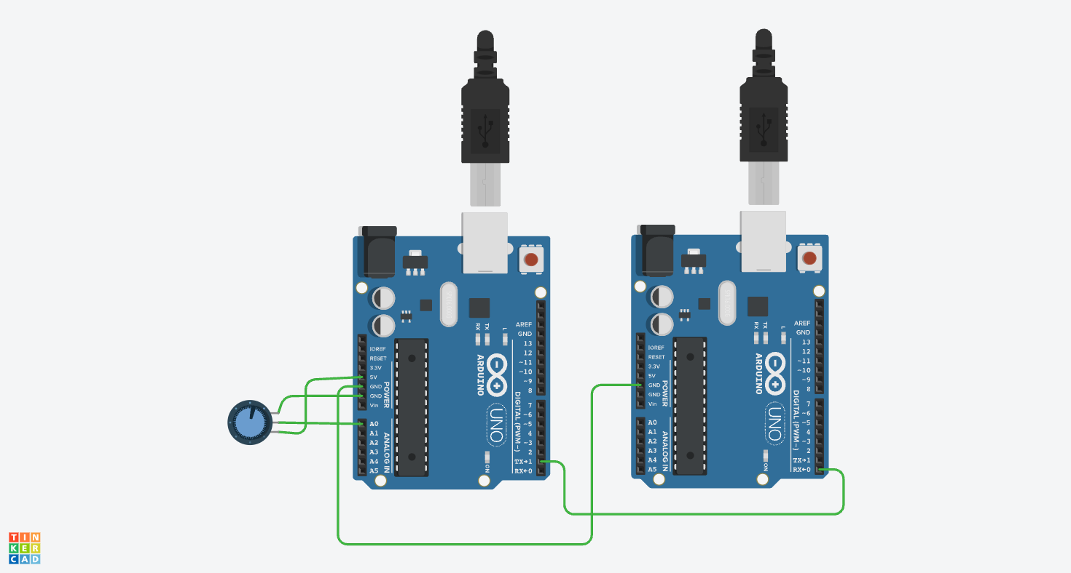

Errors: -
Code getting stuck after 1 loop
Rate of signal transmitted from Arduino 1 to 2 is faster that 2 was receiving.
Careful of delay time

Code:-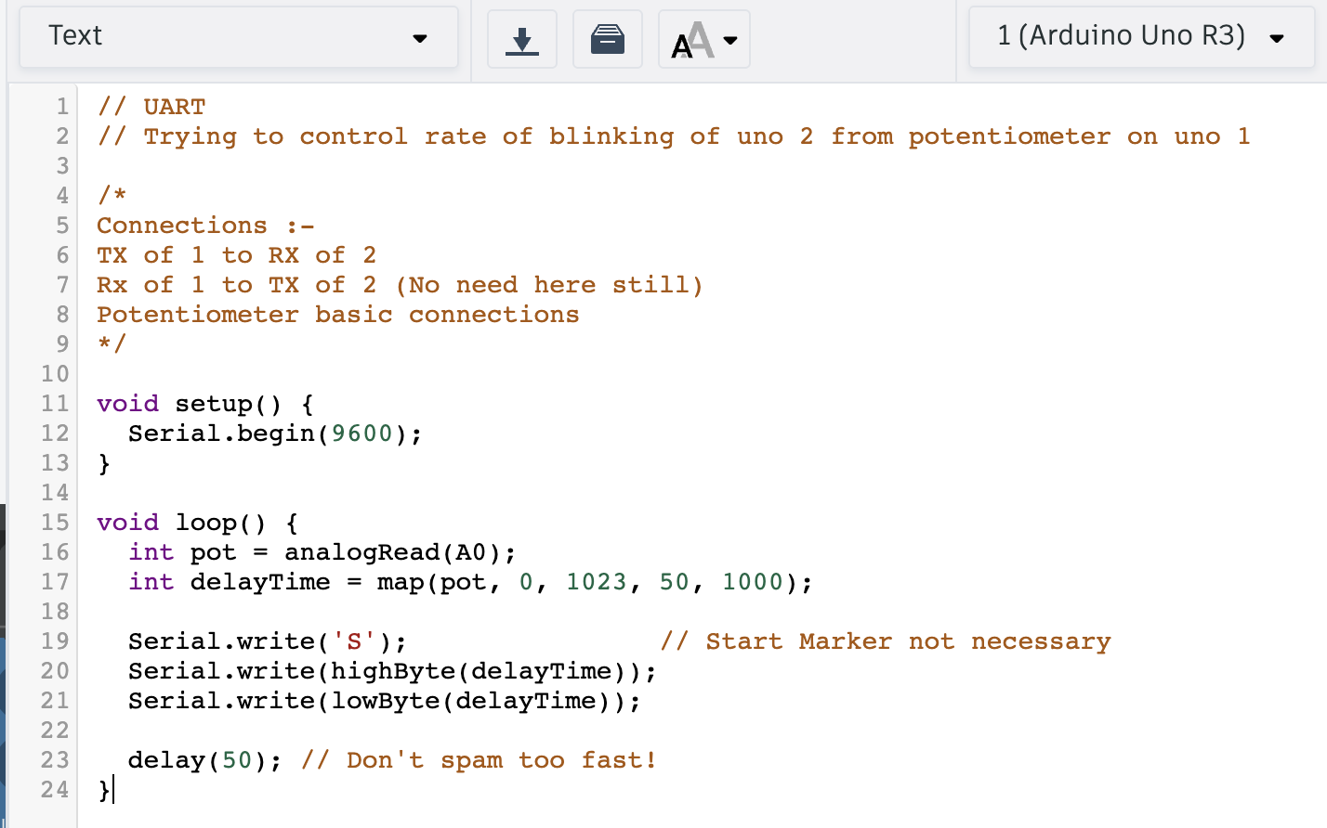
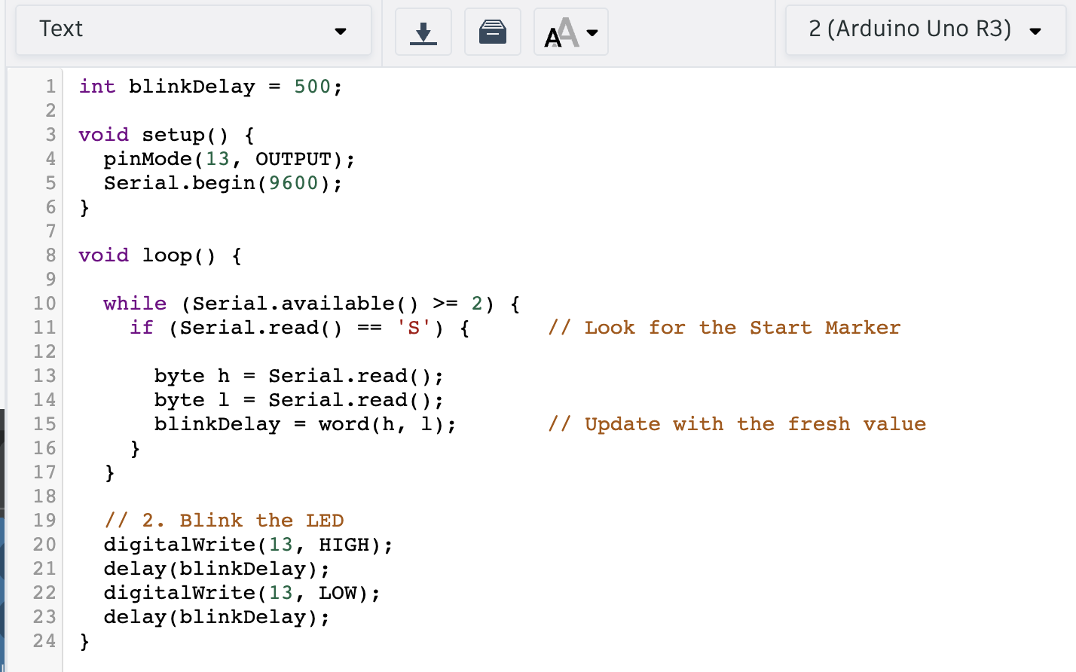

I2C
Source: -
https://youtu.be/PnG4fO5_vU4?si=ukWBM8Nigyx-fAJL
(Includes explanation for doing it using 2 Arduino’s and a way to do it)

With help of a sensor (MPU6050): -

Communicating address: -
Both code and output on serial monitor.
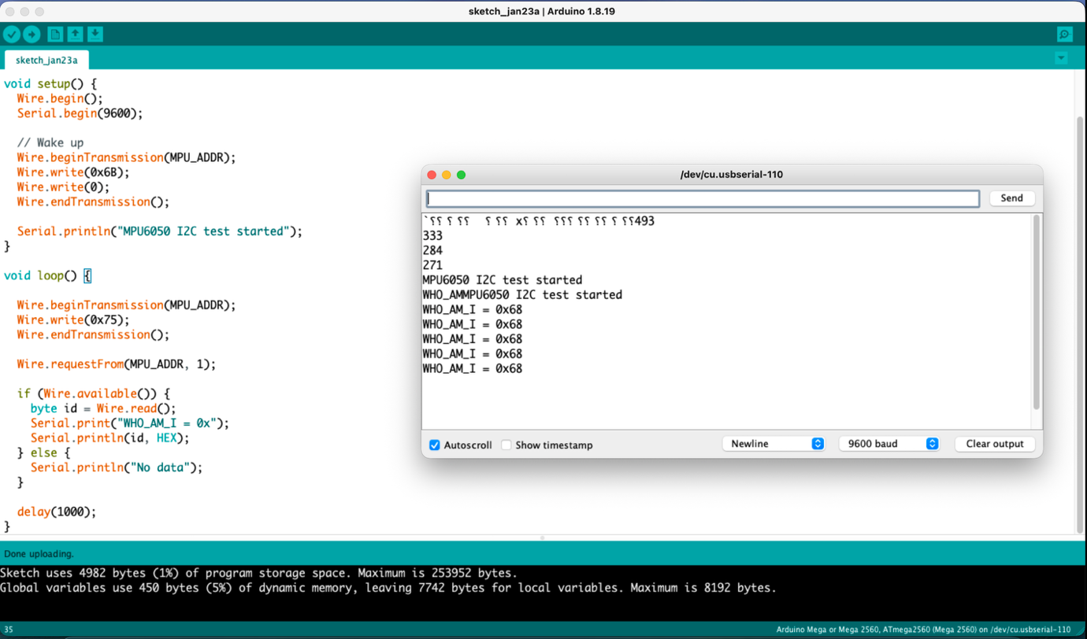

Reading values: -
Source: - (Includes Code and circuit)
https://youtu.be/wTfSfhjhAU0?si=Mapu0m8XEwmF9uGW
Output on Serial Monitor received: -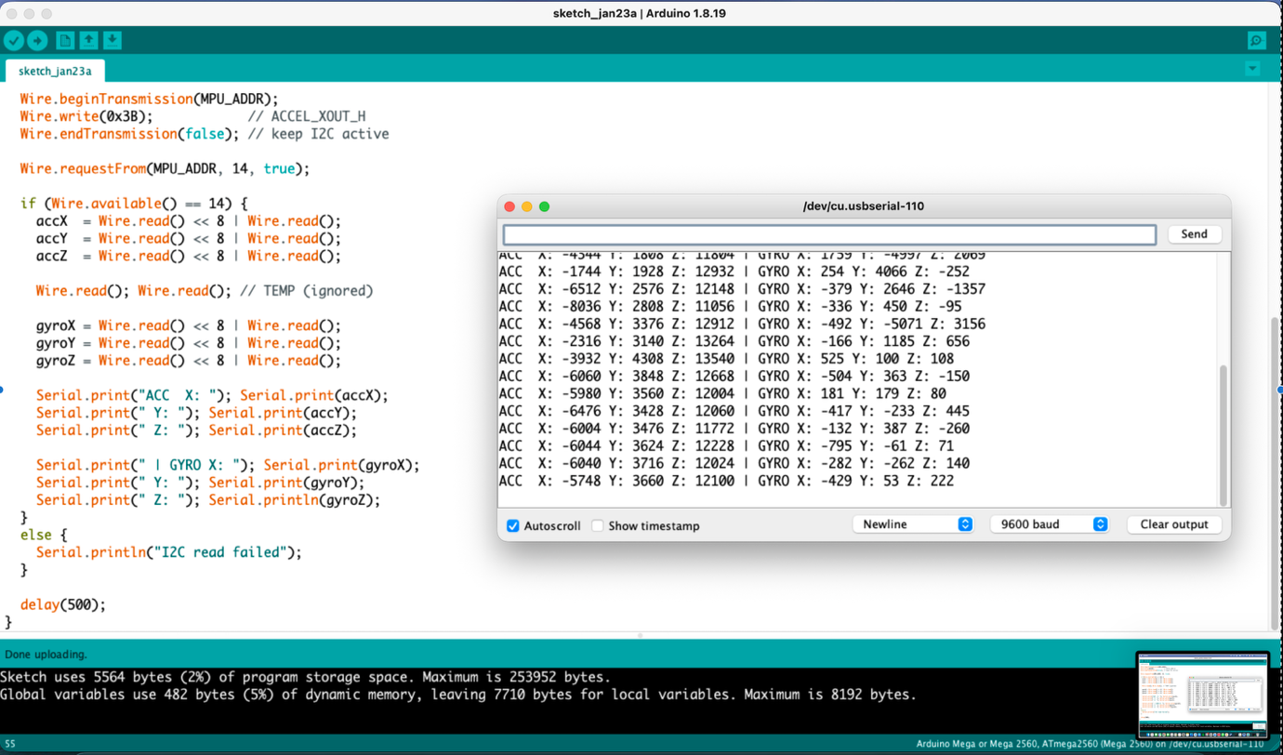

Errors: -
Non-operational Jumpers
With Help of 2 Arduino’s
Code: -
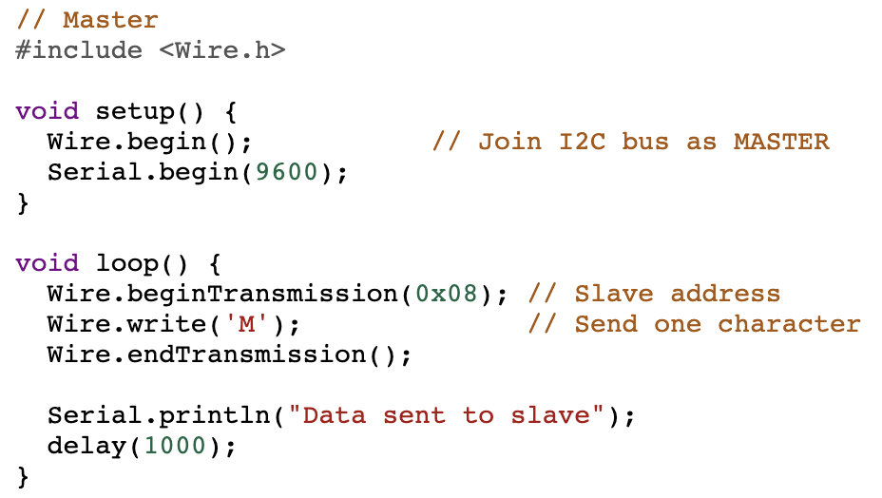
Output: -
Data sent to slave
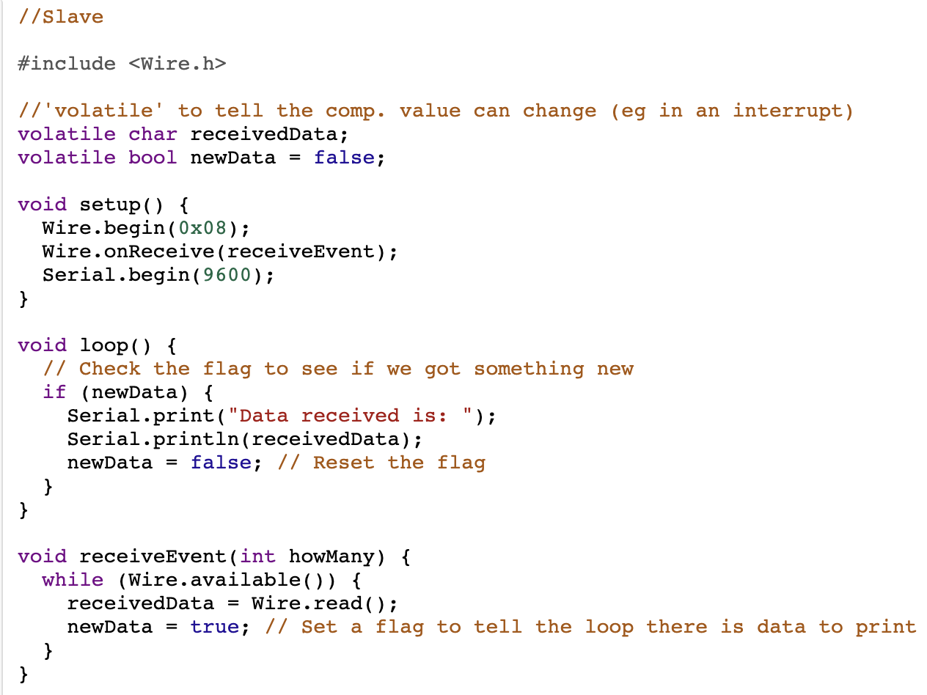
Output: -
Data received is: M

Errors: -
Using 2 different boards the can change the pins
SPI
Source: -
https://youtu.be/0nVNwozXsIc?si=EhzBryv0a35jzUyM and
https://youtu.be/IyGwvGzrqp8?si=v3_1BoAlRnNa4gUn

